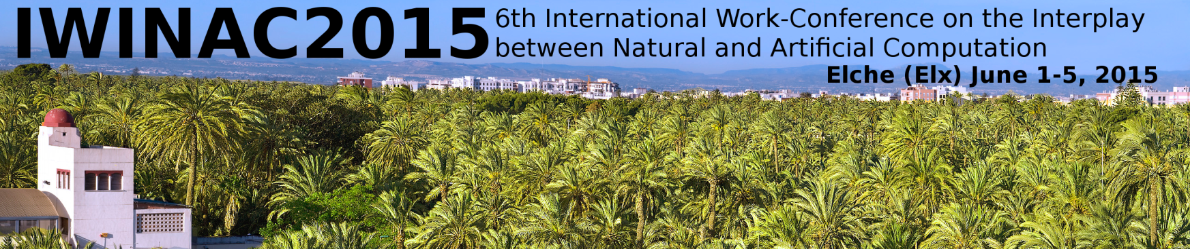

Before April 30th / After April 30th

STANDARD FEE (*): 500.00 € / 600.00 €

SESSION ORGANIZER(*): 400.00 € / 500.00 €

ATTENDANT A (**): 175.00 € / 175.00 €

ATTENDANT B (**): 100.00 € / 100.00 €

FOR ANY EXTRA PAPER: 300.00 € / 350.00 €

(*) Includes coffee breaks, meals, social events (welcome reception cocktail) and the
“Lecture Notes in Computer Science” books ( Springer-Verlag) of the work-conference proceedings.
(**) Includes social events (welcome reception cocktail). Type A registration also includes meals.

- Information of the assistant:

Name and Surname __________________________________________________________________
Address____________________________________________________________________________
City_____________________________ Zip Code ______________ Phone N.____________________
Fax___________________ Email _______________________ NIF/Passport Nº__________________

Data for Invoice:
Name and Surname / Company ______________________________________________________
Address____________________________________________________________________________
Zip Code ________ City _____________________________ Country______________________
Phone N.____________________ Fax N. ___________________

PAYMENT:
I enclose copy of bank transfer of €uros _______________ for Viajes Hispania, S.A., in Bank of Sabadell. Account number: 0081-0180-77-0001033812 (transference from Spain). For transference from abroad, add this IBAN code: ES48 before 0081 0180 77 0001033812.
Include Reference: IWINAC 2015 + YOUR NAME
I am paying by the following credit card: VISA MASTERCARD AMERICAN EXPRESS and I authorize the charge of €uros__________________ to my card

Card Number _ _ __ ___ _ _ ___ _ _ ________ _ _ _ Expiration Date _ ___/___ _

Card Holder__________________________________ Signature__________________________

Reservations can only be confirmed after reception of full payment.

SEND TO:
VIAJES HISPANIA, S.A. Att: Beatriz Baeza
Dpto de Congresos Phone: (+34) 96 522 83 93
Avda Maisonnave, nº11, 7ª plta Fax: (+34) 96 522 98 88
03003 – ALICANTE E-mail: bbaeza@viajeshispania.es

