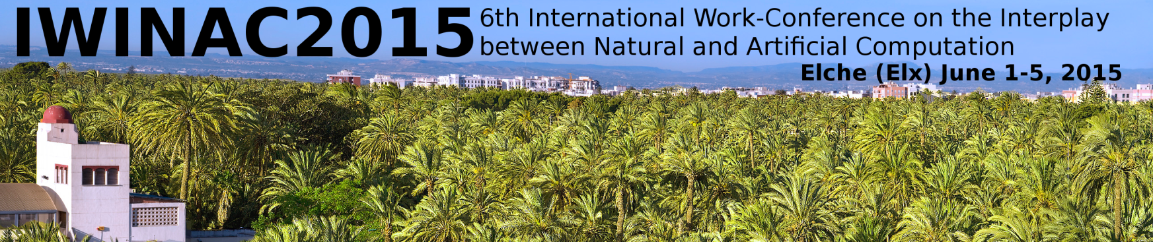

- Information of the Housing:

HOTEL | DOUBLE ROOM FOR SINGLE USE | DOUBLE ROOM
Tryp Ciudad de Elche 3* | 60,00 € | 65,00 €
H2 Elche 3* | 60,00 € | 65,00 €
Jardín Milenio 4* | 70,00 € | 70,00 €
Huerto del Cura 4* | 80,00 € | 80,00 €
Daily rates per room. Breakfast and taxes included.

- Information of the assistant:

Name and Surname __________________________________________________________________
Address____________________________________________________________________________
City_____________________________ Zip Code ______________ Phone N.____________________
Fax___________________ Email _______________________ NIF/Passport Nº__________________

Data for Invoice:
Name and Surname / Company ______________________________________________________
Address____________________________________________________________________________
Zip Code ________ City _____________________________ Country______________________
Phone N.____________________ Fax N. ___________________

PAYMENT:
I enclose copy of bank transfer of €uros _______________ for Viajes Hispania, S.A., in Bank of Sabadell. Account number: 0081-0180-77-0001033812 (transference from Spain). For transference from abroad, add this IBAN code: ES48 before 0081 0180 77 0001033812.
Include Reference: IWINAC 2015 + YOUR NAME
I am paying by the following credit card: VISA MASTERCARD AMERICAN EXPRESS and I authorize the charge of €uros__________________ to my card
Card Number ___________________________________ Expiration Date _ ___/___ _

Card Holder__________________________________ Signature__________________________
Reservations can only be confirmed after reception of full payment.
Please contact us at bbaeza@viajeshispania.es

SEND TO:
VIAJES HISPANIA, S.A. Att: Beatriz Baeza
Dpto de Congresos Phone: (+34) 96 522 83 93
Avda Maisonnave, nº11, 7ª plta Fax: (+34) 96 522 98 88
03003 – ALICANTE E-mail: bbaeza@viajeshispania.es

